

POST AND TELECOMMUNICATIONS INSTITUTE OF TECHNOLOGY
FACULTY OF INFORMATION TECHNOLOGY 1



SUBJECT : Business Intelligence
Topic: Hệ thống BI phân tích dữ liệu phim

Class : E22HTTT
Group : 19
Member : Trần Nhật Minh - B22DCVT350
Nguyễn Hoàng Nguyên - B22DCVT383

Lecturer : Kim Ngọc Bách

Hanoi, 2026
Content
Introduction 4
CHAPTER I: INTRODUCTION & BUSINESS UNDERSTANDING 5
1.1. Project Overview 5
1.2. Problem Statement 5
1.3 Business Intelligence System Objectives 6
1.4 Target End-Users & Stakeholders 6
CHAPTER II: DATASET DESCRIPTION 6
2.1 General Overview 6
2.2 Dataset Attributes & Schema Details 7
2.3 Post-Cleansing Executive Summary 9
CHAPTER III: DATA WAREHOUSE DESIGN 9
3.1 Rationale for Architecture and Data Model Selection 9
3.2 Comprehensive Data Dictionary & Schema Specification 10
3.2.1 Central Fact Table: fact_movie 10
3.2.2 Dimension Tables 12
3.2.3 Many-to-Many Relationship Bridge Table (bridge_movie_genre) 14
3.3 Data Warehouse Entity-Relationship Diagram 15
3.4. Data Warehouse Implementation 16
CHAPTER IV: ETL Process 16
4.1 Step 1: Data Extraction (Extract) 17
4.2 Step 2: Data Transformation (Transform) 17
4.2.1 Filtering and Restricting the Data Timeframe 17
4.2.2 Handling Duplicates and Missing Values 17
4.2.3 Time Dimension Transformation 17
4.2.4 Unnesting Multi-valued Movie Genres (Genre Multi-valued Transformation) 18
4.2.5 Calculated Measures 18
4.3 Step 3: Data Loading (Load) 18
CHAPTER V: DASHBOARD DEVELOPMENT 19
5.1 Core Key Performance Indicators (KPI Cards & DAX Measures) 19
5.2 Page 1: Financial Performance Overview 20
5.2.1 Interactive Filtering Components (Slicers) 20
5.2.2 Visual Component Breakdown 21
5.3 Page 2: Genre Insights & Analytics 22
5.3.1 Genre Key Performance Indicators (Genre KPIs) 22
5.3.2 Visual Component Breakdown 23
5.4 Page 3: Time Trends & Market Split Analysis 24
5.4.1 Strategic Time Key Performance Indicators (Time KPIs) 24
5.4.2 Visual Component Breakdown 25
5.5 Page 4: Rating & Top Performers 26
5.5.1 Advanced Classification Key Performance Indicators (KPIs) 26
5.5.2 Visual Component Breakdown 27
5.6. Advanced Dashboard Interactivity Mechanisms (Interactions) 28
CHAPTER VI: Insight Analysis 29
6.1 Insight 1: Cash Flow Structural Shifts and Content Globalization Strategies 29
6.2 Insight 2: The Portfolio Paradox — Corporate Revenue Scale vs. Capital Efficiency (ROI) 30
6.3 Insight 3: Seasonality Matrix Laws and the Art of Defining the "Golden Release Window" 31
6.4 Insight 4: Severe Market Polarization and the Structural Anatomy of a "Blockbuster" 31
CHAPTER VII: CONCLUSION AND FUTURE DEVELOPMENT 32
7.1 Conclusion 32
7.2 Project Limitations 33
7.3 Future Development Paths 33
CHAPTER VIII: REFERENCES 34

Introduction
In the current era of digital transformation, the cinematic industry has evolved far beyond creative artistry—it is now an intensive numbers game driven by data. With the explosive expansion of digital distribution channels and a massive volume of annual theatrical releases, thoroughly decoding audience tastes, optimizing box office monetization, and forecasting macroeconomic market shifts have become existential requirements for production studios and distribution companies alike.
However, film-related data structures typically reside in highly fragmented silos—spanning box office cash flows, critical reviews, social media engagement sentiments, and granular metadata covering cast, crew, and genre categories. The fundamental challenge lies in how to seamlessly ingest, blend, and consolidate these isolated pipelines into valuable, actionable insights capable of guiding high-stakes business decision-making.
Driven by these critical industry dynamics, our team selected the research topic: "Building a Business Intelligence (BI) System for Movie Data Analytics." This project goes beyond engineering storage models and handling transformations within a centralized Data Warehouse; it focuses directly on the interactive visualization of pivotal corporate metrics. These include mapping temporal shifts in genre market share, evaluating the direct economic correlations between production budgets and actual worldwide gross revenues, and segmenting consumer demand configurations based on authoritative audience rating matrices.
Through the deployment of this enterprise analytics solution, our team aims to deliver a holistic, data-driven view of the global cinematic landscape, thereby providing high-value strategic frameworks to optimize future film production pipeline selection and promotional marketing campaigns.

CHAPTER I: INTRODUCTION & BUSINESS UNDERSTANDING

1.1. Project Overview
In recent years, the motion picture industry has experienced exponential growth, characterized by a vast diversity of genres, countries of origin, and distribution channels (ranging from traditional theatrical releases to modern streaming platforms). Consequently, every film release generates a massive volume of data, which can be categorized into three primary domains:
- Identity & Metadata: Movie title, release date, and original language.
- Financial Metrics: Production budget alongside domestic and international box office revenues.
- Audience Reception Data: Average audience rating, total user vote count, and a popularity score.

1.2. Problem Statement
Despite the abundance of available data, studio executives and industry investors frequently confront the following systemic challenges:
- Data Fragmentation: Operational data is siloed across disparate platforms (review aggregate websites, theatrical box office reports, and streaming platform analytics), making manual data consolidation incredibly labor-intensive and time-consuming.
- Difficulty in Isolating Correlations: It is highly challenging to rapidly extract actionable answers to cross-functional business questions, such as: "Does a low-budget film with high critical acclaim stand a strong chance of commercial success?" or "Which genres deliver the highest return on investment relative to their production budget?"
- Lack of Predictive Capability: Without a centralized, holistic view derived from historical data trends, allocating capital and greenlighting new film projects remains a highly volatile and risky endeavor.

1.3 Business Intelligence System Objectives
The primary objectives of building this specialized Movie Analytics BI System include:
- Establishing a Centralized Data Warehouse: Automating the extraction, cleansing, and loading (ETL) of a single consolidated movie dataset (final_dataset.csv) into a unified, single source of truth.
- Data Visualization & Reporting: Transforming raw, complex data tables into highly interactive dashboards, allowing stakeholders to intuitively track market dynamics and trends over time.
- Strategic Decision Support: Delivering deep-dive analytical reports focused on:
  - Revenue, profit, and ROI performance across genres and original languages.
  - The relationship between production budget, box office revenue, and profitability.
  - Return on Investment (ROI) efficiency across genres and release periods.

1.4 Target End-Users & Stakeholders
- Film Producers & Studio Executives: To guide capital allocation and greenlight projects based on genre, budget, and release-timing performance.
- Distributors & Theater Operators: To optimize release-window planning based on data-backed seasonal revenue trends.
- Cinema Market Researchers: To thoroughly analyze historical data and forecast future trajectories within the motion picture industry.

CHAPTER II: DATASET DESCRIPTION

2.1 General Overview
The dataset utilized in this project is sourced from the "Movie Revenue Analysis" repository by ntdoris (GitHub - ntdoris/movie-revenue-analysis). The raw data is hosted in the final_dataset.csv file, which aggregates comprehensive attributes including movie profiles, box office revenues, production costs, profitability metrics, user ratings, release dates, original languages, and associated genres.
The initial raw dataset contained 1,759 records spanning a release timeline from 1946 to 2019. However, during data profiling and exploration, the team observed that the volume of films prior to 2010 was sparse and unevenly distributed, while the year 2019 contained insufficient records. Therefore, to ensure data consistency and statistical reliability when analyzing financial performance and market trends, the team restricted the primary analytical scope to the 2010–2018 period.
Following the data cleaning and preprocessing phases, the finalized dataset comprises 1,541 unique movie records distributed across a 9-year span (2010–2018). The data has been deduplicated based on movie titles and release years. Furthermore, all critical fields—including revenues, production budgets, profits, ROI, rating scores, and vote counts—contain valid, fully populated values.

2.2 Dataset Attributes & Schema Details
The primary attribute groups within the processed dataset consist of:
- Movie Metadata: Movie title, release date, release month, release year, and original language.
- Financial Metrics: Production budget, domestic gross, international gross, worldwide gross, and net profit.
- Business Performance Indicators: Profit margin, Return on Investment (ROI), and international revenue ratio.
- Audience Reception Metrics: Average user rating, total vote count, and popularity score.
- Genre Classifications: Action, Adventure, Comedy, Drama, Horror, Thriller, Science Fiction, Animation, Family, and other miscellaneous genres.
The principal attributes of the consolidated final_dataset.csv source are summarized below: :
Attribute | Description
title | Movie title.
release_date | Theatrical release date (used to derive year, month, quarter, and season).
original_language | Original language of the film.
genres | One or more genre labels assigned to the film (multi-valued).
production_budget | Total production cost (USD).
domestic_gross | Box office revenue in the domestic market (USD).
foreign_gross | Box office revenue in international markets (USD).
worldwide_gross | Total worldwide box office revenue (USD).
profit | Net profit (worldwide_gross − production_budget).
profit_margin | Profit as a share of worldwide revenue.
roi | Return on investment (profit / production_budget).
pct_foreign | Share of worldwide revenue generated from foreign markets.
vote_average | Average audience rating on a 10-point scale.
vote_count | Total number of user votes.
popularity | Popularity score.

The annual distribution of the 1,541 unique movie records across the selected analytical timeframe is broken down as follows:
- 2010: 188 movies
- 2011: 192 movies
- 2012: 168 movies
- 2013: 184 movies
- 2014: 183 movies
- 2015: 204 movies
- 2016: 167 movies
- 2017: 131 movies
- 2018: 124 movies (marking the lowest production output within the observed period)

2.3 Post-Cleansing Executive Summary
The high-level statistical profile of the finalized dataset is summarized below:
- Total Analytical Sample Size: 1,541 unique movie records
- Analytical Timeframe: 2010–2018 (9-year span)
- Cumulative Global Revenue: Approx. 207.82 billion USD
- Cumulative Production Budget: Approx. 65.77 billion USD
- Cumulative Net Profit: Approx. 142.05 billion USD
- Overall ROI Factor: Approx. 2.16x
- Average Audience Rating: Approx. 6.25 / 10
- Distinct Genre Classifications: 19 genres
- Distinct Original Languages: 20 languages
This processed dataset is highly aligned with Business Intelligence (BI) requirements, as it provides a comprehensive suite of quantitative metrics necessary for deep-dive analysis of box office revenues, profitability, ROI dynamics, temporal seasonality, genre efficiency, and organic audience reception. Following the preprocessing phase, this structured data is successfully ingested into the Data Warehouse utilizing a Star Schema architecture, paving the way for interactive dashboard development and strategic insight extraction.

CHAPTER III: DATA WAREHOUSE DESIGN

3.1 Rationale for Architecture and Data Model Selection
For this project, the Data Warehouse is designed using a Star Schema model, which is widely used in Business Intelligence systems due to its simplicity, query efficiency, and suitability for analytical reporting.
The main objective of the data model is to support movie revenue analysis across multiple dimensions, including time, movie title, genre, and original language. The central table of the model is the fact_movie table, which stores quantitative measures such as production budget, domestic gross, foreign gross, worldwide gross, profit, profit margin, ROI, rating, vote count, and popularity. Around this fact table are several dimension tables that provide descriptive context for analysis.
The system also includes a bridge table named bridge_movie_genre because a single movie can belong to multiple genres. For example, a movie such as Avengers: Infinity War may be classified as Action, Adventure, and Science Fiction at the same time. A direct one-to-many relationship between movie and genre would not be sufficient, so the bridge table is used to represent this many-to-many relationship.
The selected model provides the following advantages:
Optimized analytical queries: Power BI can aggregate revenue, profit, and ROI efficiently through direct relationships between the fact table and dimension tables.
Clear separation between measures and dimensions: Numeric business metrics are stored in fact_movie, while descriptive attributes are stored in dimension tables.
Reduced data redundancy: Movie, time, language, and genre information are stored separately instead of being repeated across the fact table.
Accurate genre analysis: The bridge table allows movies with multiple genres to be analyzed correctly.
Scalability: The model can be extended in the future with additional dimensions such as country, production company, director, or actor if richer datasets are integrated.

3.2 Comprehensive Data Dictionary & Schema Specification
The Data Warehouse consists of the following tables:
Fact_movie | dim_movie | dim_time | dim_language |dim_genre | bridge_movie_genre

The model follows an enhanced Star Schema structure. The fact_movie table is the central fact table, while dim_movie, dim_time, and dim_language are directly connected to it. The genre dimension is connected through the bridge_movie_genre table to support the many-to-many relationship between movies and genres.

3.2.1 Central Fact Table: fact_movie
The fact_movie table stores the main quantitative measures used for analysis. Each record in this table represents the performance metrics of one movie in the cleaned dataset.

Column | Data type | Key/Role | Description
fact_id | SERIAL | PK | Unique identifier of each fact record.
movie_id | INT | FK | References dim_movie(movie_id).
time_id | INT | FK | Foreign Key linking to dim_time (Surrogate Key mapping to the time dimension table).
language_id | INT | FK | Foreign Key linking to dim_language (Surrogate Key mapping to the language dimension table).
production_budget | BIGINT | Measure | The total financial cost incurred to produce the film (Unit: USD).
domestic_gross | BIGINT | Measure | Box office gross revenue generated in the domestic market (USD)
foreign_gross | BIGINT | Measure | Box office gross revenue generated in the international market (USD)
worldwide_gross | BIGINT | Measure | Total box office gross revenue generated worldwide (USD)
profit | BIGINT | Measure | Net profit generated (= worldwide_gross − production_budget).
profit_margin | NUMERIC(10,4) | Measure | Profit margin ratio.
roi | NUMERIC(10,4) | Metric | Return on Investment (ROI = profit / budget).
pct_foreign | NUMERIC(10,4) | Measure | Share of worldwide revenue generated from foreign markets.
vote_average | NUMERIC(4,2) | Measure | Average audience rating on a 10-point scale.
vote_count | INT | Measure | Total number of user votes submitted.
popularity | NUMERIC(10,3) | Measure | The metric measuring the system's movie popularity score.

The fact_movie table enables core analytical questions such as:
Which years generated the highest worldwide revenue?
Which genres achieved the highest ROI?
Which movies became blockbusters?
What is the relationship between production budget and revenue?
How much revenue came from domestic versus foreign markets?

3.2.2 Dimension Tables
a. Movie Dimension Table (dim_movie) Stores qualitative, detailed, and static descriptive attributes of each film.
Fields: movie_id (PK), title, release_date, source_id.
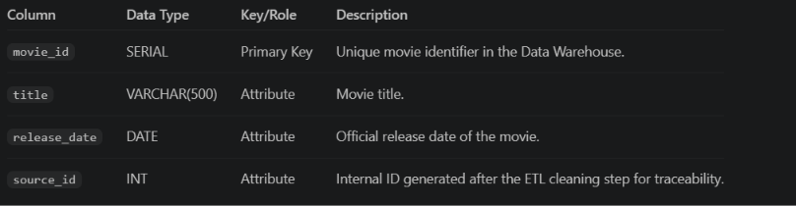

b. Time Dimension Table (dim_time) Designed to granularly break down the release date into distinct attributes for deep cyclical time-series analysis.
Fields: time_id (PK), full_date, year, quarter, month, month_name, day, day_of_week, decade, season, is_weekend.
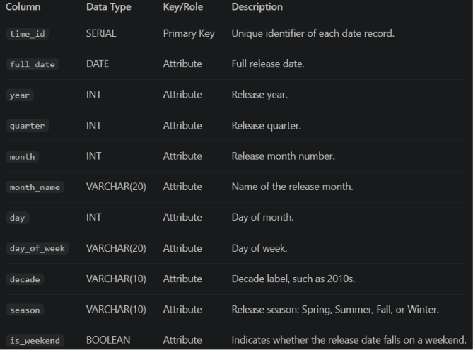
This dimension allows the dashboard to analyze revenue, profit, movie count, and ROI by year, month, quarter, season, and weekend release status.

c. Language Dimension Table (dim_language) Used to analyze the movie market based on the linguistic origin.
Fields: language_id (PK), language_code, language_name.

This dimension supports analysis of movie performance by original language.
d. Genre Dimension Table (dim_genre) Contains the movie classification categories used to evaluate market preferences and tastes.
Fields: genre_id (PK), genre_name.



3.2.3 Many-to-Many Relationship Bridge Table (bridge_movie_genre)
A technical intermediary table that maps a single movie to multiple genres without violating data warehouse design principles.
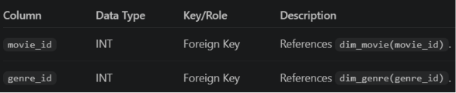
The combination of movie_id and genre_id is used as the composite primary key. This prevents duplicate movie-genre relationships and ensures that genre-based filtering works correctly in Power BI.
For example, if a movie belongs to Action, Adventure, and Science Fiction, the bridge table stores three rows for that movie, one for each genre. This design allows Power BI to filter movies by genre while still keeping the main fact table clean.

3.3 Data Warehouse Entity-Relationship Diagram
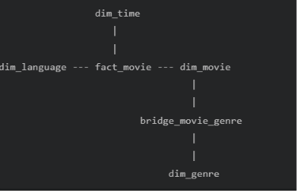

dim_movie.movie_id → fact_movie.movie_id (One-to-many) One movie dimension record can be linked to fact record(s). In the current dataset grain, each movie has one fact record.
dim_time.time_id → fact_movie.time_id (One-to-many) One date can be associated with many movies released on that date.
dim_language.language_id → fact_movie.language_id (One-to-many) One language can be associated with many movies.
dim_movie.movie_id → bridge_movie_genre.movie_id (One-to-many) One movie can have multiple genre mappings.
dim_genre.genre_id → bridge_movie_genre.genre_id (One-to-many) One genre can be linked to many movies.
In Power BI, these relationships allow filters from dimensions to propagate to the fact table. For example, when a user selects the year 2015, Power BI filters dim_time, then retrieves the corresponding records in fact_movie to calculate revenue, profit, ROI, and movie count for that year.
Similarly, when a user selects the Action genre, the filter goes from dim_genre to bridge_movie_genre, then to dim_movie, and finally to fact_movie. This enables accurate genre-based analysis without storing repeated genre values directly in the fact table.

3.4. Data Warehouse Implementation
The ETL pipeline is implemented in Python using pandas, SQLAlchemy, and psycopg2. The processed data is loaded into PostgreSQL tables in the following order:
dim_time | dim_movie | dim_genre | dim_language | fact_movie | bridge_movie_genre
Before reloading data, the pipeline truncates the existing tables using:
TRUNCATE TABLE
bridge_movie_genre,
fact_movie,
dim_movie,
dim_time,
dim_genre,
dim_language
RESTART IDENTITY CASCADE;
This ensures that every ETL run refreshes the Data Warehouse with a clean and consistent dataset.
After loading, the final Data Warehouse contains:
fact_movie: 1,541 rows
dim_movie: 1,541 rows
dim_time: 710 rows
dim_genre: 19 rows
dim_language: 20 rows
bridge_movie_genre: 3,926 rows
This structure provides a consistent analytical foundation for the Power BI dashboard and supports the main business questions of the project, including revenue trends, genre performance, ROI analysis, market split, rating distribution, and top-performing movies.

CHAPTER IV: ETL Process
The ETL process serves as the "lifeline" that circulates and standardizes data from the primary source (CSV file) to the centralized Data Warehouse. The team's ETL system is designed as an automated pipeline using Python (utilizing the pandas library for data structure processing) combined with a relational database management system to ensure data integrity and consistency.

4.1 Step 1: Data Extraction (Extract)
The initial raw data is extracted from the final_dataset.csv file from the Movie Revenue Analysis research source.
- Source Characteristics: The file contains 1,759 records representing multi-dimensional information of movies from 1946 to 2019.
- Programmatic Solution: The pipeline utilizes the pandas.read_csv() function to load the entire raw dataset into memory (DataFrame) as a tabular structure to begin the initial data quality assessment.

4.2 Step 2: Data Transformation (Transform)
This is the most complex stage in the pipeline, focusing on data cleaning, filtering the research scope, and restructuring fields to align with the Star Schema model. The detailed transformation steps include:

4.2.1 Filtering and Restricting the Data Timeframe
- Raw Data Issue: Surveying the data revealed that records prior to 2010 were highly sparse and inconsistent; additionally, the year 2019 contained too little data, introducing noise into trend analysis.
- Solution: The pipeline implements a logical filter to retain only movies with release years ranging from 2010 to 2018. Following this step, the dataset is streamlined to 1,541 movies, ensuring high representativeness and consistency.

4.2.2 Handling Duplicates and Missing Values
- Duplicate records are checked and completely removed based on a unique identifier pair: Movie Title and Release Year.
- For quantitative financial attributes (production_budget, domestic_gross, foreign_gross, worldwide_gross) and rating metrics (vote_average, vote_count), the system checks for null/missing values (Null/NaN). Invalid cases are either standardized to default values or dropped if they violate data constraints.

4.2.3 Time Dimension Transformation
- The initial raw release date field is cast to a standard Date/Time format (datetime64).
- The pipeline automatically parses this field into independent attributes: Day (day), Month (month), and Year (year). Concurrently, a logical function is applied to calculate the Quarter (quarter) attribute based on the month value to support cyclical business analysis reporting.

4.2.4 Unnesting Multi-valued Movie Genres (Genre Multi-valued Transformation)
- Issue: In the raw data, a single movie contains a comma-separated list of multiple genres or is stored as a string list (e.g., "Action, Adventure, Sci-Fi").
- Solution:
  - The pipeline applies string splitting techniques to break down the genre string of each movie into an array list.
  - It then loops over the resulting genre list and creates one movie-genre mapping row per genre for bridge_movie_genre, rather than using a vectorized explode operation.
  - A unique list of genres is generated to load into dim_genre, while the movie key - genre key mapping pairs are preserved to populate the bridge_movie_genre table, thoroughly resolving the Many-to-Many relationship.

4.2.5 Calculated Measures
To reduce the computational overhead on the Dashboard layer, derived metrics are computed directly within the ETL layer:
- Profit: Calculated using the formula:
Profit = worldwide_gross − production_budget
- Return on Investment (ROI): Calculated using the formula:
ROI = profit / production_budget

4.3 Step 3: Data Loading (Load)
Once the data is thoroughly cleaned and structured within the DataFrame layer, the pipeline separates and loads the data into the target tables in the SQL Data Warehouse in a strict order of priority to prevent Foreign Key constraints violations:
- Dimensions Loading (Independent dimension tables loaded first):
  - Load data into the dim_time table (containing unique day, month, year, and quarter combinations).
  - Load data into the dim_language table (containing a catalog of 20 original languages).
  - Load data into the dim_genre table (containing a catalog of 19 independent movie genres).
- Dependent Dimension Loading:
  - Load identifying information for the 1,541 movies into the dim_movie table.
- Facts & Bridges Loading:
  - Load all financial metrics and ratings of the 1,541 movies, along with their corresponding foreign keys, into the central fact_movie table.
  - Finally, load the key mapping pairs into the bridge_movie_genre table.
The loading process first truncates the existing warehouse tables (TRUNCATE ... RESTART IDENTITY CASCADE), then reloads the cleaned data using to_sql with if_exists="append", ensuring the data warehouse is always ready for Power BI connection and exploitation.

CHAPTER V: DASHBOARD DEVELOPMENT
The Data Visualization Layer was practically implemented by the research team using the Microsoft Power BI Desktop platform. It connects directly to the Data Warehouse hosted on the relational database management system via Import Mode to optimize data rendering speeds, query responsiveness, and analytical calculation performance.
Regarding the User Interface and User Experience (UI/UX) design, the Dashboard layout adopts a standard 16:9 aspect ratio with a minimalist and modern aesthetic. A light background theme is paired with a high-contrast color palette (utilizing commercial blue as the primary color for revenue bars, complemented by distinct shades of red, purple, and yellow for market share segmentation). This design enables decision-makers to rapidly spot financial highlights and operational risks. The reporting suite is structured into four distinct report pages, corresponding to business analysis tracks that span from macro overviews to micro-level details.

5.1 Core Key Performance Indicators (KPI Cards & DAX Measures)
To provide an instantaneous and holistic view of the financial health and operational scale of the film industry from 2010 to 2018, the team established a dedicated row of permanent KPI Cards embedded in the Header (topmost section) of the report pages. These metrics are not available in the raw source data; instead, they are computed dynamically at runtime using Data Analysis Expressions (DAX):
- Total Revenue Card: Displays 207.82B. This metric gauges the total volume of box office cash flow generated across both domestic and international markets.
  - DAX Formula:
Total Revenue = SUM(fact_movie[worldwide_gross])

- Total Net Profit Card: Reflects the actual commercial surplus retained after deducting production costs, reaching 142.05B. This indicator helps shareholders and investors accurately evaluate economic efficiency rather than relying solely on raw gross revenue.
  - DAX Formula:
Total Profit = SUM(fact_movie[profit])

- Total Movies Card: Displays 1,541 movies. This card identifies the exact sample size under evaluation, ensuring statistical representation and data reliability for analytical findings.
  - DAX Formula:
Total_Movies = COUNTROWS(dim_movie)

5.2 Page 1: Financial Performance Overview
This report page delivers a strategic, comprehensive overview of revenue migration trends, profit structures over time, and market-driving segments.

5.2.1 Interactive Filtering Components (Slicers)
- Page Navigator: Elegantly designed at the bottom edge of the Dashboard, featuring custom navigation buttons that allow users to switch rapidly between the four research modules: Overview, Genre Analysis, Time Trends, and Rating & Top Performers.
- Advanced Filter Slicer: Positioned at the top right corner, enabling users to dynamically filter the dataset by original language (original_language) and release year to observe real-time variations across all underlying visuals.

5.2.2 Visual Component Breakdown
1. Visual 1: Annual Revenue, Budget, and Profit Trends
  - Visual Type: Line Chart.
  - Horizontal Axis (X-Axis): Time dimension field dim_time[year] spanning from 2010 to 2018.
  - Vertical Axis (Y-Axis): Total cumulative worldwide revenue (Sum of worldwide_gross), scaled from 20B to over 24B.
  - Analytical Value: Enables strategists to track the industry's annual growth acceleration. The chart clearly outlines a strong upward rally from 2011 to 2014, a sharp downturn in 2015, followed by a historical peak in 2016 (approaching the 25 Billion threshold).

2. Visual 2: Profit by Year
  - Visual Type: Clustered Column Chart.
  - Horizontal Axis (X-Axis): dim_time[year].
  - Vertical Axis (Y-Axis): Represents the calculated measure [Total_Profit] in billions of USD (ranging from 0B to 20B).
  - Analytical Value: Serves as a vital complement to the revenue trend chart. It reveals that despite shifting gross revenues, the industry's net profit margins maintained robust stability, consistently fluctuating between 13 Billion and 17 Billion annually.

3. Visual 3: Top 10 Movies by Revenue
  - Visual Type: Clustered Bar Chart.
  - Vertical Axis (Y-Axis): Movie title attribute dim_movie[title].
  - Horizontal Axis (X-Axis): Individual film gross revenue (Top 10 Movie Revenue from 0B to 2B).
  - Analytical Value: Automatically ranks and highlights the highest-grossing commercial champions in cinematic history, led by the blockbuster Avengers: Infinity War, which set a historic record by crossing the 2 Billion mark.

4. Visual 4: Revenue Structure by Movie Genre
  - Visual Type: Donut Chart.
  - Legend: Movie genre classifications dim_genre[genre_name].
  - Values: Aggregate gross revenue paired with its respective percentage contribution.
  - Analytical Value: Maps out the distribution of box office market share. The chart highlights the two main pillars driving global revenue: Adventure at 103 Billion (accounting for 16.11%) and Action at 102 Billion (accounting for 16.02%).

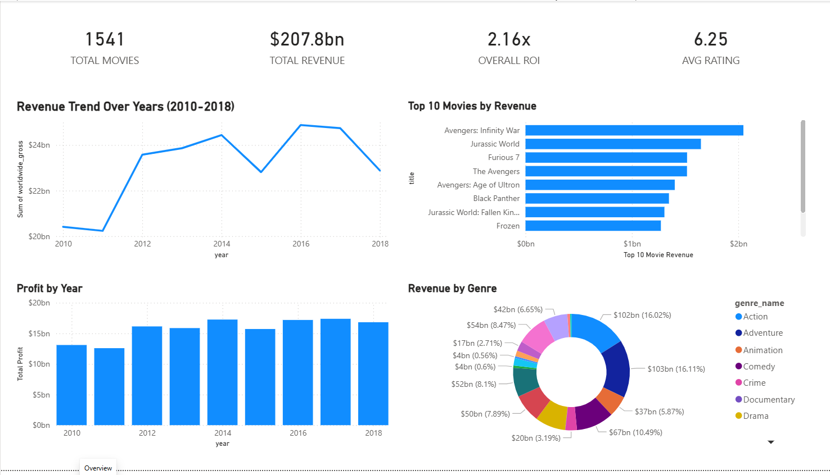

5.3 Page 2: Genre Insights & Analytics
This report page serves as the technical core of the project, leveraging data from the bridge_movie_genre table to dissect the commercial performance of specific movie genres. It addresses the fundamental business question: "Which genre segment should capital be allocated to in order to maximize efficiency and minimize business risks?"

5.3.1 Genre Key Performance Indicators (Genre KPIs)
This page integrates three dynamic KPI cards that automatically recalculate based on user cross-filtering interactions:
- BEST GENRE: Displays Adventure. This identifies the leading genre by aggregate box office revenue in the market.
- BEST GENRE BY AVG ROI: Displays Horror. A highly strategic metric proving that the horror genre is the most capital-efficient segment.
- GENRE COUNT: Displays 19. This indicates the total number of movie genres tracked and classified by the system.

5.3.2 Visual Component Breakdown
1. Visual 1: Production Volume by Genre (Movies Count per Genre)
  - Visual Type: Clustered Bar Chart.
  - Vertical Axis (Y-Axis): Genre name field dim_genre[genre_name].
  - Horizontal Axis (X-Axis): Total volume of movies produced (Movies per Genre).
  - Analytical Value: Measures market competition density and production saturation. The chart indicates that Drama (728 movies) and Comedy (514 movies) are the most heavily produced, whereas Horror sits near the bottom with a relatively modest volume.

2. Visual 2: Total Revenue Matrix by Genre (Revenue per Genre)
  - Visual Type: Clustered Bar Chart.
  - Vertical Axis (Y-Axis): dim_genre[genre_name].
  - Horizontal Axis (X-Axis): Total Revenue, with a macro-scale reaching up to 0.1T (100 Billion).
  - Analytical Value: Allows a direct comparison between production volume (market supply) and resulting cash flows to clearly reveal which genres generate the most significant returns.

3. Visual 3: Efficiency Mapping (Avg Budget vs. Avg Revenue by Genre)
  - Visual Type: Scatter Chart.
  - Horizontal Axis (X-Axis): Average production budget per movie (Avg Budget per Movie, scaled from 0.0B to 0.1B).
  - Vertical Axis (Y-Axis): Average revenue per movie within the genre (Avg Revenue per Movie in Genre, scaled from 0.0B to 0.4B).
  - Analytical Value: Segments and positions market status. The data points located in the top-right quadrant represent the high-cost, high-return "Blockbuster" segment, consisting of Adventure and Action. The data points positioned on the far-left margin represent the cost-optimized segments.

4. Visual 4: Comprehensive Genre Matrix (Genre Matrix Table)
  - Visual Type: Table Visual.
  - Fields Displayed: genre_name, Movies per Genre, Total Revenue, Avg ROI, Avg Rating.
  - Analytical Value: Provides absolute data accuracy for granular lookup. The table exposes a critical insight: although Action generates a massive revenue of over 102 Billion, its average ROI is only 1.63x. In contrast, other genres deliver vastly superior capital returns (e.g., Animation at 2.58x and Family at 2.25x).

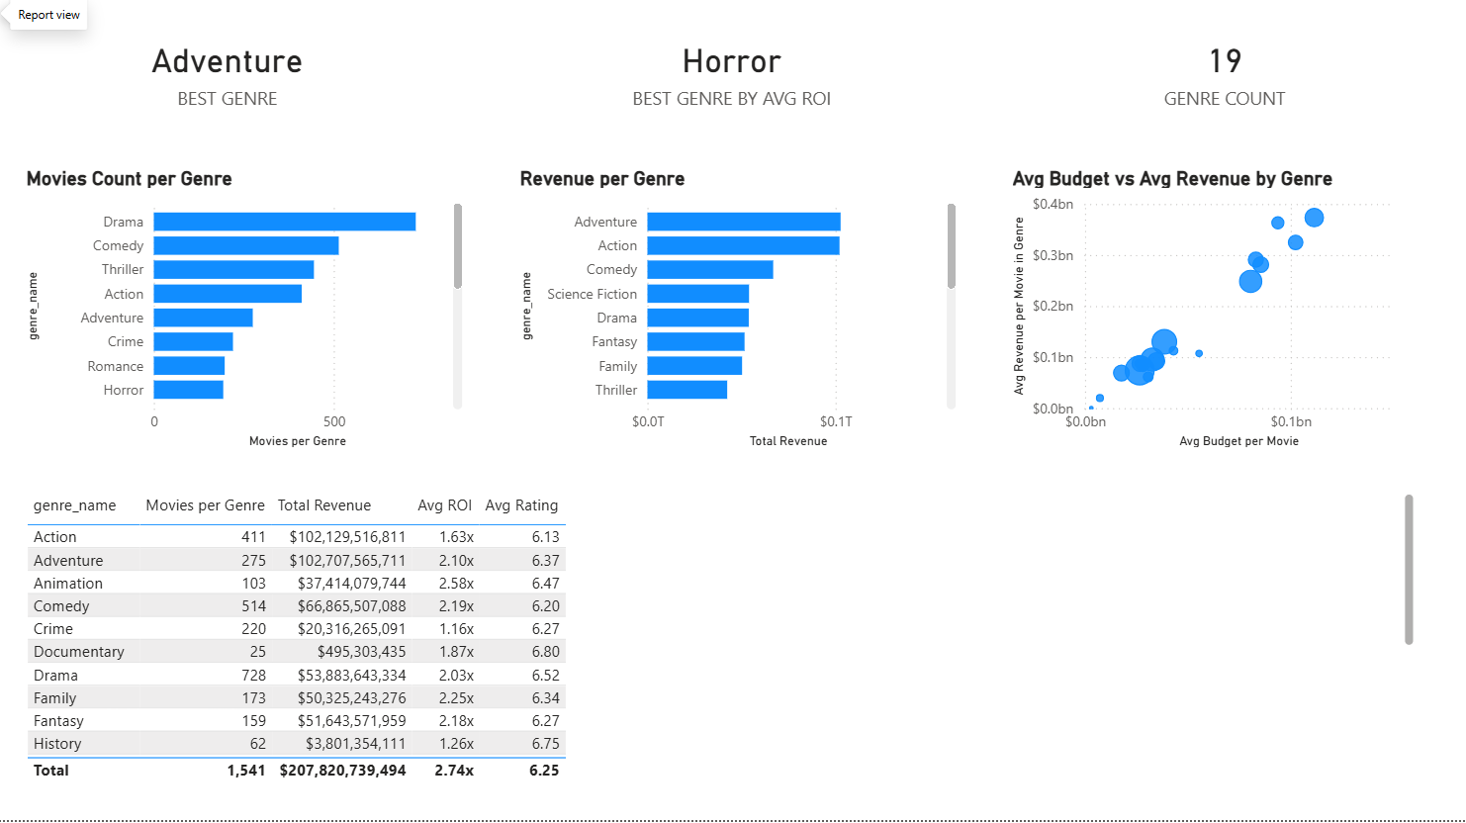

5.4 Page 3: Time Trends & Market Split Analysis
This report page combines financial metrics with qualitative indicators (ratings, popularity scores) to uncover the formula for box office success. The primary objective of this module is to dissect historical data across distinct temporal grains (Years, Months) to identify release patterns and cyclical trends in cinematic consumer behavior.

5.4.1 Strategic Time Key Performance Indicators (Time KPIs)
- BEST MONTH: Displays June. This identifies the month that triggers the highest revenue and box office performance of the year.
- SUMMER %: Displays 30.0%. This indicates that the summer months alone account for nearly one-third of aggregate annual revenue.
- HOLIDAY %: Displays 22.8%. This represents the cash flow contribution share generated during major holiday seasons.

5.4.2 Visual Component Breakdown
1. Visual 1: Capital Efficiency Trajectory (Avg ROI by Year)
  - Visual Type: Clustered Column Chart.
  - Horizontal Axis (X-Axis): dim_time[year].
  - Vertical Axis (Y-Axis): Average ROI (Avg ROI), scaled from 0x to 4x.
  - Analytical Value: Evaluates how market capital efficiency fluctuates over time. The year 2015 registered an exceptional peak, with the average ROI crossing the 4x profit threshold.

2. Visual 2: Production Volume Trends (Movie Count per Year)
  - Visual Type: Line Chart.
  - Horizontal Axis (X-Axis): dim_time[year].
  - Vertical Axis (Y-Axis): Total volume of movies produced (Total Movies, ranging from 150 to over 200 films).
  - Analytical Value: Exposes a striking market reality: movie production volume peaked in 2015 (with over 200 titles) but subsequently plummeted vertically to a record low in 2018 (dropping to just over 100 titles). This may indicate either a lower number of recorded films in the dataset or a shift toward fewer high-revenue releases in the selected sample.

3. Visual 3: Seasonality Matrix (Revenue by Month)
  - Visual Type: Clustered Column Chart.
  - Horizontal Axis (X-Axis): Month names dim_time[month_name].
  - Vertical Axis (Y-Axis): Total Revenue, scaled from 0B to over 20B.
  - Analytical Value: Visually diagnoses market seasonality. The chart explicitly shows massive revenue spikes concentrated in June, May, and November. Conversely, months such as January and September experience the lowest box office performance troughs.

4. Visual 4: Market Share Contribution (Domestic vs. Foreign Revenue)
  - Visual Type: Pie Chart.
  - Components: Foreign Revenue and Domestic Revenue.
  - Analytical Value: Proves the economic contribution structure of the industry. International markets hold a dominant position, contributing 125 Billion (equivalent to 60.1%), whereas the domestic market brings in 83 Billion (equivalent to 39.9%).

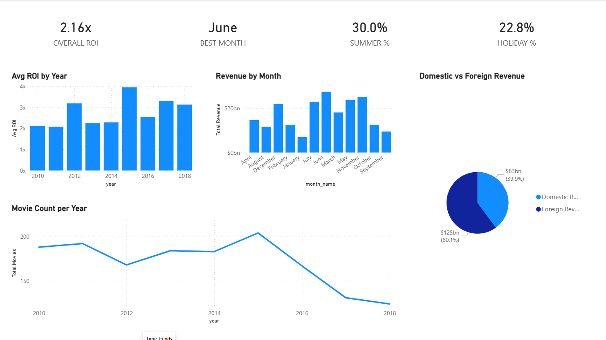

5.5 Page 4: Rating & Top Performers
This report page serves as a diagnostic module, delving deep into the correlation between artistic quality/audience taste (represented by user ratings) and the actual commercial performance of individual movies. Consequently, it enables administrators to profile exceptionally successful blockbusters or identify box office failures.

5.5.1 Advanced Classification Key Performance Indicators (KPIs)
To assist management in segmenting the operational quality of film investments, the team developed four intelligent KPI cards powered by advanced conditional filtering logic:
- AVG RATING Card: Displays the baseline standard of 6.25 for the entire data warehouse.
- BLOCKBUSTERS Card: Displays 27 titles. This tracks the elite cohort of movies that vastly outperformed the market by crossing the billion-dollar worldwide revenue threshold.
- FLOPS Card: Displays an alarming 469 movies. This represents high-risk financial projects whose box office gross failed to recover production costs (negative net profit) or yielded critically low profitability margins.
- PROFITABLE % Card: Displays 69.6%. This indicates that out of every 10 movies released in theaters, approximately 7 successfully achieved a break-even point or generated a profit.

5.5.2 Visual Component Breakdown
1. Visual 1: User Rating Distribution Matrix (Rating Distribution)
  - Visual Type: Histogram Chart.
  - Horizontal Axis (X-Axis): Average user rating fact_movie[vote_average] scaled from 0 to 10.
  - Vertical Axis (Y-Axis): Total volume of movies produced (Total Movies, ranging from 0 to 100 films).
  - Analytical Value: The chart reflects a near-perfect normal distribution. The frequency peaks are heavily concentrated within the 5.5 to 7.0 score range, proving that the vast majority of produced films achieve acceptable to fair quality, while cinematic disasters or masterpieces account for a very small fraction of the market.

2. Visual 2: Efficiency and Return Mapping (Budget vs. Revenue by Movie)
  - Visual Type: Scatter Chart.
  - Horizontal Axis (X-Axis): Total investment capital (Total Budget, scaled from 0.0B to 0.4B).
  - Vertical Axis (Y-Axis): Total gross revenue (Total Revenue, scaled from 0B to 2B).
  - Analytical Value: Each blue data point plots the economic coordinates of a specific movie. This chart assists investors in instantly spotting massive margin outliers—most notably the points detached at the top apex, which approached 1.5B to 2.0B in revenue while maintaining average budgets of only 200M to 300M.

3. Visual 3: Top Revenue Earners Ledger (Top 20 Movie Revenue)
  - Visual Type: Table Visual.
  - Fields Displayed: title, Top 20 Movie Revenue, Total Budget, Avg ROI, Avg Rating, and Total Votes.
  - Analytical Value: Provides a micro-level financial lookup table for the most commercially successful films in box office history. For instance, the ledger clearly exposes that the blockbuster Furious 7 achieved an ROI of 6.99x, while the animated feature Frozen delivered a staggering performance of 7.48x.
  - Total Summary Row: Displays the aggregate metrics of the entire storage system, showing a Total Revenue of 207,820,739,494, a Total Budget of 65,767,816,823, an Average ROI of 2.74x, an Average Rating of 6.25, and capturing 3,125,144 total user votes.

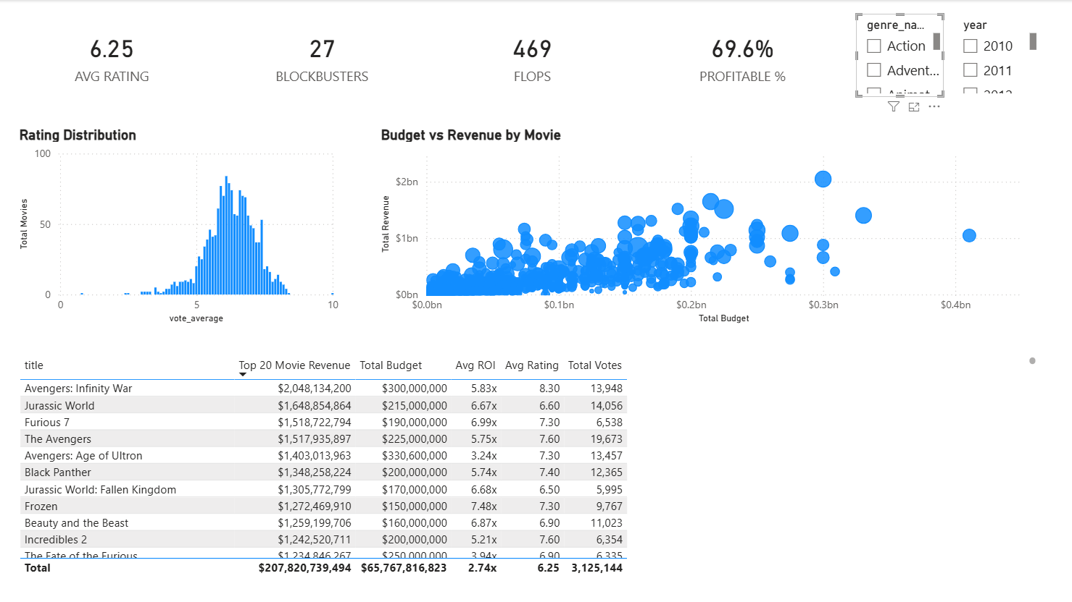

5.6. Advanced Dashboard Interactivity Mechanisms (Interactions)
The true capabilities of the research team's Business Intelligence solution lie not merely in displaying isolated, static charts, but in the successful configuration of a dynamic communication network between visual components, driven by a tightly integrated star-schema Data Warehouse:
- Automated Cross-filtering & Cross-highlighting: Because all dimension and fact tables are synchronized and standardized, when an administrator clicks on a specific data point—such as the "2015" data point on the trend line chart on Page 1 or the "Action" genre row on Page 2—all remaining visual components (from international revenue structures and risk scatter plots to micro-level data tables) instantly trigger underlying filters to recalculate values, reflecting only the scope of the selected entity.
- Time-based Analysis: For charts containing temporal attributes, time-based visuals allow users to analyze performance by year and month, breaking down annual aggregates into monthly metrics to support detection of seasonal fluctuations.
- Dynamic Hover Details (Tooltips): To optimize screen real estate and prevent visual clutter caused by dense text blocks, the team integrated intelligent Tooltips. When a user hovers the cursor over any revenue column, genre donut segment, or individual movie data point on a scatter matrix, a compact pop-up tooltip automatically appears. This dialog box rapidly extracts hidden parameters such as Movie Title, Exact Genres, Domestic Revenue, International Revenue, Specific ROI, and Cumulative Votes without requiring the user to click or switch pages.

CHAPTER VI: Insight Analysis
Through the operationalization of the interactive data visualization Dashboard built upon the standardized Data Warehouse, the research team conducted deep-dive analyses to uncover underlying patterns, financial migration trends, and highly actionable strategic insights. These data-driven findings deliver essential architectural benchmarks to help strategists, production studios, and institutional investors optimize resource allocation and mitigate systemic risks within the global cinematic ecosystem.

6.1 Insight 1: Cash Flow Structural Shifts and Content Globalization Strategies
Evaluating the cross-functional data relationships across reporting modules—specifically the Domestic vs. Foreign Revenue pie chart on Page 3 and the Annual Revenue, Budget, and Profit Trends line chart on Page 1—exposes a critical, defining law of box office geography:
- The Absolute Dominance of International Markets: The underlying data demonstrates that international market returns (Foreign Revenue) command an overwhelming share of 60.1% (equivalent to 125B), whereas internal markets (Domestic Revenue) account for a mere 39.9% (equivalent to 83B) of aggregate organizational cash flows. This distribution is further corroborated by the Revenue by original_language matrix on Page 1, where English-language ("en") intellectual properties aggressively outperform all other language variations combined.
- Actionable Business Lesson: The era where major studios could sustain profitability by exclusively catering to domestic consumer preferences has permanently concluded. Modern filmmaking is a global export commodity. For an upcoming project to secure a position among the "Top Performers" or successfully breach the billion-dollar milestone, it must be architected with a globalization mindset from the early scriptwriting phases. This mandates prioritizing English as the primary vehicle language, crafting universally relatable narratives, minimizing hyper-localized cultural dependencies, and embedding high-spectacle visual engineering to effortlessly bypass cross-border linguistic barriers.

6.2 Insight 2: The Portfolio Paradox — Corporate Revenue Scale vs. Capital Efficiency (ROI)
An analysis of the scatter chart matrix tracking Avg Budget vs. Avg Revenue by Genre paired with the Comprehensive Genre Matrix Table on Page 2 uncovers a fascinating economic paradox separating two distinct movie genre categories:
- The "Market Share Anchors" (Action & Adventure): These two segments operate as the largest macro-financial engines of the entire industry, generating massive aggregate gross revenues of 102,129,516,811 and 102,707,565,711 respectively. However, due to the high-cost production thresholds (Budget) structurally inherent to these genres, their average Return on Investment (Avg ROI) sits at a highly conservative 1.63x for Action and 2.10x for Adventure.
- The "Margin Outliers" (Horror, Animation, Family): While the Horror genre sits at the bottom tier regarding production volume (193 titles) and generates lower aggregate gross revenue (approximately $13.29B), the analytics platform identifies it as the Best Genre by Avg ROI, at roughly 8.36x. Concurrently, the Animation and Family segments deliver exceptional capital yield margins, achieving outstanding average returns of 2.58x and 2.25x respectively. This performance stems from an optimized cost structure characterized by low baseline production budgets that yield high explosive box-office ratios when successfully capturing family demographics or psychological horror trends.
- Actionable Business Lesson: For corporate finance officers, this variance forms the foundation of modern Portfolio Management within entertainment assets. Independent studios, venture capital funds, or newly entering operators should strategically allocate resources toward Horror or Animation pipelines—capital entry barriers are low, payback periods are compressed, and the margin of safety is structurally superior. Conversely, the billion-dollar Action/Adventure playground is exclusively viable for multinational media conglomerates with massive cash reserves that intentionally accept compressed yields in exchange for high-volume cash flows to consolidate market share and scale brand equity.

6.3 Insight 3: Seasonality Matrix Laws and the Art of Defining the "Golden Release Window"
By diagnosing temporal performance vectors across the Avg ROI by Year column visualization and the Revenue by Month seasonality matrix on Page 3, the research team isolated highly predictable, cyclical consumer behaviors:
- The "Summer Blockbuster" and "Q4 Holiday" Spikes: System-wide cash flows do not distribute linearly across the 12 calendar months; instead, they consolidate into two macroeconomic peak waves. The primary wave crests across May and June, with June surfacing as the definitive Best Month for box office velocity—perfectly aligning with a Summer % metric that holds 30.0% of annual revenue. The secondary surge manifests in November, capturing the high-conversion pre-Christmas holiday window. In stark contrast, January and September collapse into commercial troughs where box office revenues hit baseline floors.
- Actionable Business Lesson: Optimizing the Release Window Strategy is a high-stakes operational decision that dictates a project's financial survival. Distributors must strictly schedule high-budget flagship properties within the May-to-July window to fully absorb the surging consumer demand of student demographics entering summer vacations. Conversely, historical low-velocity months like September or January should be utilized as safe tactical landing zones for low-budget independent features or arthouse cinema—properties that bypass intensive box office pressures and instead optimize theater screen utilization once major studio blockbusters have exited the circuit.

6.4 Insight 4: Severe Market Polarization and the Structural Anatomy of a "Blockbuster"
By extracting advanced diagnostic metrics from Page 4 (Rating & Top Performers), the data reveals a brutal, asymmetric market polarization conforming closely to the Pareto Principle (80/20) within the entertainment economy:
- The Profitability Paradox: While the data warehouse reports a healthy macroeconomic profitability ratio (PROFITABLE %) of 69.6%, analyzing absolute numbers exposes a punishing reality: loss-making or financially stranded titles (FLOPS) encompass a massive volume of 469 movies, whereas elite assets classified as true market champions (BLOCKBUSTERS) total a mere 27 movies. Simultaneously, the Rating Distribution histogram reveals a powerful quality-clustering effect, with the overwhelming majority of titles locked within a safe, mediocre performance tier ranging from 5.5 to 7.0 user points.
- The Structural Formula of Top Performers: Granular inspection of the top 20 highest-grossing titles indicates that market leaders (such as Avengers: Infinity War, Jurassic World, and Furious 7) share an identical structural footprint: an elite qualitative user rating tier (Avg Rating consistently scaling between 6.60 and 8.30) coupled with a viral, explosive audience feedback loop reflected in massive engagement volumes (Total Votes ranging from 11k to nearly 20k submissions per title).
- Actionable Business Lesson: The film industry operates on a classic Long-tail model heavily dominated by Winner-Take-All dynamics. The staggering returns generated by the 27 elite blockbusters possess the financial scale to fully absorb the capital write-offs of 469 underperforming assets while single-handedly sustaining the holding corporation's annual profit margins. To gain entry into this exclusive 27-movie "Blockbuster Club," producers cannot afford to execute middle-of-the-road, mediocre projects (the 5.0–6.0 rating trap). Management must focus resources on forcing the core narrative asset into a high-quality tier (Rating > 6.5), while aggressively funding marketing campaigns engineered to stimulate digital community engagement, drive user interactions (Total Votes), and trigger exponential Word-of-Mouth (WoM) network effects that break a film out of the safety baseline into hyper-profitable performance zones.

CHAPTER VII: CONCLUSION AND FUTURE DEVELOPMENT

7.1 Conclusion
Through the process of researching, designing, and practically implementing the project "Building a Business Intelligence System to Analyze the Global Cinematic Market (2010 - 2018)", the research team has successfully fulfilled all initial objectives, delivering the following core deliverables:
- Data Infrastructure and Architecture: The team successfully engineered a robust Data Warehouse optimized using a Star Schema model. The Extraction, Transformation, and Loading (ETL) pipeline was strictly executed, thoroughly resolving issues of missing data or formatting anomalies, and seamlessly handling the complex many-to-many relationship between movies and genres via a strategic bridge table (bridge_movie_genre).
- Visualization and Analytics (BI): A comprehensive four-page interactive Dashboard (Overview, Genre Analysis, Time Trends, and Rating & Top Performers) was successfully deployed on Power BI. Moving beyond static reporting, the system offers dynamic interactivity through slicers, cross-filtering, cross-highlighting, tooltips, and time-based visual analysis.
- Actionable Business Value: The system effectively deciphered underlying operational laws within this multi-billion-dollar industry. These range from confirming the absolute dominance of international markets (commanding 60.1% of gross revenue) and exposing the high-margin paradox of low-budget segments like Horror (yielding the most optimized ROI), to mapping the "golden release windows" (May and June) and uncovering the structural formula required to join the elite 27-movie Blockbuster club. These insights serve as a high-value decision-making asset for cinematic strategists.

7.2 Project Limitations
While achieving highly favorable outcomes, the system possesses several objective limitations that require transparent acknowledgment:
- Temporal Boundaries: The current dataset is bounded within the 2010–2018 timeframe. Consequently, the macroeconomic shifts that occurred post-2018—most notably the explosive rise of Over-The-Top (OTT) streaming platforms such as Netflix and Disney+ during and after the pandemic—are not yet integrated, leaving modern digital distribution trends unreflected.
- Absence of Secondary Analytical Dimensions: The current Data Warehouse concentrates heavily on box office gross, production budgets, and user scores. It currently lacks deeper integrations with structural dimensions such as distribution companies (Distributors), talent equity (Cast & Crew reputation indices), or localized demographic breakdowns within individual international territories.

7.3 Future Development Paths
To enhance the commercial viability and analytical depth of the system moving forward, the team has outlined the following strategic expansion paths:
- Automating and Expanding the Data Pipeline: Engineering automated web-scraping modules or establishing direct API connections with industry-standard authoritative repositories (e.g., IMDb, Box Office Mojo, TMDB) to transition the data pipeline into a real-time ingestion engine, extending the analytical scope up to the current year.
- Integrating Digital Streaming Dimensions: Incorporating performance metrics unique to streaming video-on-demand (SVOD) assets—such as viewership metrics, audience retention rates, and subscriber churn correlation—to model comparative analytics between traditional theatrical circuits and digital platforms.
- Upgrading to Predictive Analytics: * Deploying Machine Learning (ML) architectures, such as linear regression or decision tree algorithms, to forecast the prospective box office revenue of a film project during its pre-production phase based on composite attributes (Genre + Estimated Budget + Target Release Month).
  - Integrating natural language processing (NLP) for Sentiment Analysis across social media ecosystems (e.g., Facebook, X, Reddit) to enrich the system's popularity metrics, enabling production studios to execute real-time PR crisis management.

CHAPTER VIII: REFERENCES
- Inmon, W. H. (2005). Building the Data Warehouse (4th ed.). John Wiley & Sons.
(Fundamental textbook defining centralized data warehouse architecture, storage layers, and methodologies for designing enterprise data systems).
- Kimball, R., & Ross, M. (2013). The Data Warehouse Toolkit: The Definitive Guide to Dimensional Modeling (3rd ed.). John Wiley & Sons.
(The core theoretical foundation applied for star schema designs, dimension table and fact table configurations, and the implementation of bridge tables to handle many-to-many relationships).
- McKinney, W. (2022). Python for Data Analysis: Data Wrangling with pandas, NumPy, and Jupyter (3rd ed.). O'Reilly Media.
(The definitive technical manual utilized for data cleaning, data profiling, and DataFrame manipulation within the Transformation stage of the ETL pipeline).
- Ferrari, A., & Russo, M. (2019). The Definitive Guide to DAX: Business Intelligence with Microsoft Power BI, SQL Server Analysis Services, and Excel (2nd ed.). Microsoft Press.
(Technical guide applied to optimize complex DAX metrics, manage filter contexts, and configure analytical calculation layers across the reporting dashboard).
- Few, S. (2013). Information Dashboard Design: Displaying Data for At-a-Glance Monitoring (2nd ed.). Analytics Press.
(Academic textbook for user interface and user experience (UI/UX) design principles, standard 16:9 layout configurations, and high-contrast corporate data visualization).
- Vogel, P. (2011). The Movie Industry Book: How Movies Are Made and Distributed. Hollywood Audio and Video.
(Cinematic industry framework utilized as the domain baseline to evaluate calculated business measures, return on investment thresholds, and release window dynamics).
- Elmasri, R., & Navathe, S. B. (2015). Fundamentals of Database Systems (7th ed.). Pearson.
(Standard textbook covering relational database management systems, primary/foreign key constraint modeling, and schema integrity preservation for the loading stage).
- Proby, J. (2020). Data Pipelines Pocket Reference: Moving and Processing Data for Analytics. O'Reilly Media.
(Specialized text on engineering automated data pipelines, data quality verification, and exception handling routines within standard ETL architectures).

